Viruses
What is a virus?

Viruses are usually categorized by the systems they affect. What are some categories of viruses?

How is a virus different from a bacteria?

Are viruses alive?

Properties of viruses
- no membranes, cytoplasm, ribosomes, or other cellular components
- they cannot move or grow
- they can only reproduce inside a host cell
- they consist of 2 major parts - a protein coat, and hereditary material (DNA or RNA)
- they are extremely tiny, much smaller than a cell and only visible with advanced electron microscopes
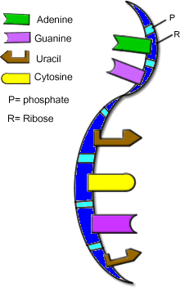
RNA is similar to DNA
Instead of thymine, it has uracil
It has the sugar ribose, instead of deoxyribose
It is single stranded

Review the structure of DNA
Shape of a double helix, repeating units of nucleotides
Base pairs held together by hydrogen bonds (weak)
Adenine -----|-----Thymine
Guanine -----|---- Cytosine
The sides of the DNA made of alternating deoxyribose (5 ring sugar) and phosphates
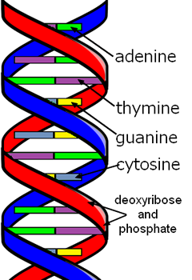

Virus Structure
Virus has a covering that has a capsid and sometimes an envelope
Inner core contains a nucleic acid molecule (DNA or RNA) and various proteins
Parasitic Nature
- Obligate intracellular parasites
- Specific to their hosts (human, bird, dog)
- They can only attack specific cells (respiratory, immune, skin)

Viral Reproduction
Lytic cycle = reproduction occurs, cells burst (See: Animation at McGraw-Hill)
Lysogenic cycle = reproduction does not immediately occur (dormancy)
Virulent = viruses that undergo both cycles
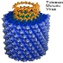
Viral Replication (see page 404-405)
Viruses multiply, or replicate using their own genetic material and the host cell's machinery to create more viruses. Viruses cannot reproduce on their own, and must infect a host cell in order to create more viruses.
1. Attachment - specific proteins on cell surface attach to the virus
(See Animation: Entry of Viruses)
2. Penetration - the virus is engulfed by the cell (Cell can enter Lysogenic or Lytic Cycle)
3. Biosynthesis - viral components are made (protein coat, capsid, DNA/RNA)
4. Maturation - assembly of viral components
5. Release - viruses leave host cell to infect new cells (often destroys host)
Image of a bacteriophage called Lambda

Types of Viruses
Bacteriophage - viruses that infect bacteria.
Retroviruses -- RNA viruses that have a DNA stage
Some viruses can be viewed using electron microscopes, they come in many distinctive shapes and can be very photogenic. Check out this Gallery at Virusworld
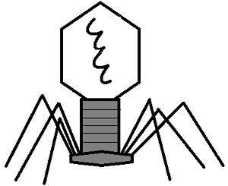

How Are Viruses Named
There is not an established method of naming viruses, and historically they have been named for a variety of factors, including:
- the associated diseases (poliovirus, rabies)
- the type of disease caused (murine leukemia virus)
- the sites in the body affected or from which the virus was first isolated (rhinovirus, adenovirus)
- where they were first isolated (Ebola virus, Hantavirus),
- for the scientists who discovered them (Epstein-Barr virus)
- the animal that carries the virus (bird flu, swine flu)
- for the way people imagined they were contracted (dengue = ‘evil spirit’; influenza = ‘influence’ of bad air).
Newer Conventions look at the molecular structure of the virus and other factors.
Example of an Influenza Virus Naming
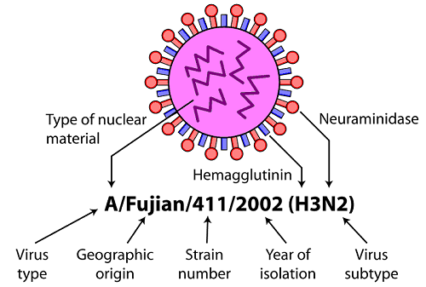

Focus on Human Immunodifiency Virus
- Causes the disease AIDS (Acquired Immune Defiency Syndrome)
- Retrovirus (RNA inside a protein coat)
- Reverse Transcriptase makes DNA from the virus RNA
- DNA inserts into host DNA
- Proteins are assembled from the DNA code
- Viruses assembled from the proteins
- Viruses released from the cell
HIV Infection Cycle (animation)
HIV Coloring Assignment

Emerging Viruses
- illnesses not previously known AIDS, West Nile Virus, SARS, Ebola, Avian Flu
- Could be mutations of known viruses
- Could be viruses exposed when new areas were developed
- Could have jumped species
Related to Viruses
Viroids - even smaller than viruses, consist of RNA strands that lack a protein coat
Prions - "rogue protein", believed to be the cause of Mad Cow Disease, also may cause Kuru in cannibal tribes
See: http://highered.mcgraw-hill.com/sites/007352543x/student_view0/chapter20/how_prions_arise.html

Treatment of Viruses
Vaccines
1.Once you have gotten a virus, such as chicken pox, your body develops the immunity to that virus.
2. Vaccines are made by growing a weakened or killed form of the virus (often grown in eggs)
3. This form of the virus is injected into a person's body, which causes an immune response, and immunity to the virus
Antiviral Drugs
There are two FDA-approved antiviral drugs recommended by CDC. The brand names for these are Tamiflu® (generic name oseltamivir) and Relenza® (generic name zanamivir).
Tamiflu binds to the active site on neuraminidase which prevents the virus from leaving the cell and infecting other cells
Other antivirals block the viruses at various stages of their life cycle, such as blocking cell receptors, preventing attachment or preventing viral repication after the virus has entered the cell.
HIV Life Cycle - drugs that affect reverse transcriptase, integrase, protease, CD4 receptors can slow the spread of the virus

Quiz: Viruses
1. A virus consists of:
RNA or DNA and a cell membrane
RNA or DNA and a protein coat
RNA and DNA and a protein coat
proteins, cell membrane and RNA
2. How do viruses reproduce?
they divide by mitosis
sexually, by external fertilization
replication outside the host
inserting DNA into the host cell
3. Which of the following is smallest?
eukaryote cell
bacteria
bacteriophage
cell membrane protein
4. Retroviruses are different from viruses in that:
they have RNA instead of DNA
they can become dormant
they are symmetrical
all of these
5. Vaccines can be used to prevent viral infection by:
creating an immune response in the host
destroying any viruses that enter the host
creating a blocking protein on the cell
preventing replication of the virus
6. Antiviral drugs that are used after infection often prevent:
cell division
immune system degradation
reinfection by other viruses
uptake of the virus
7. Why do some viruses seem to go away and then return later, like a cold sore?
host has been infected with a different strain
the immune system forgot the virus
the virus had entered the lysogenic cycle
the virus mutated
8. Why is it difficult to develop vaccines for retroviruses?
their small size evades the immune system
RNA mutates more frequently than DNA
the capsid of retroviruses is resistant
vaccines can only target blood-borne pathogens
9. Viruses are often named by:
where they were first discovered
the scientist who discovered it
the animal that carries it
all of these
10. What happens after the virus has been taken up by the cell?
it begins making protein
it divides
it inserts into the host DNA
it switches to infectious mode

