MITOTIC (M) PHASE = DIVISION OF NUCLEUS
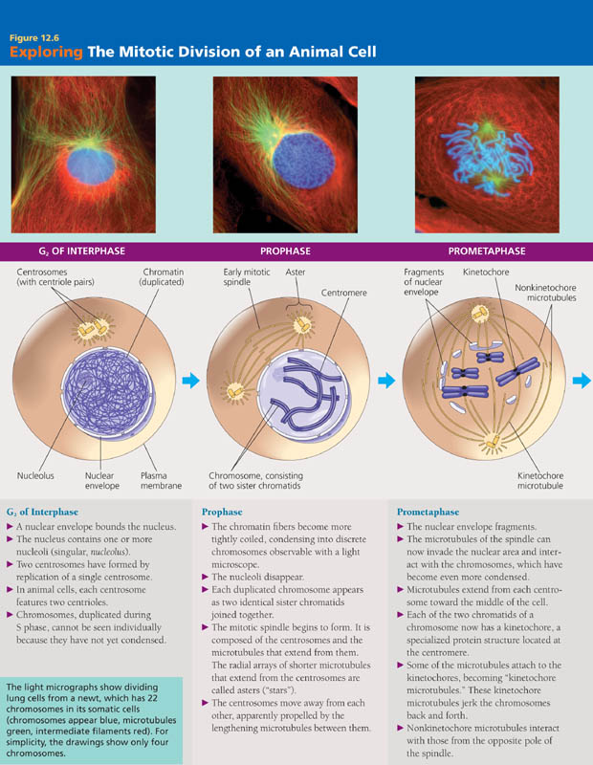
INTERPHASE = ________________________________

______________________________________________________________________________________________________________________________________________________________________________________________________________________________________________________________________________
PROPHASE
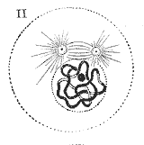
____________________________________________
____________________________________________
____________________________________________
____________________________________________

PROMETAPHASE
____________________________________________
____________________________________________
____________________________________________
____________________________________________

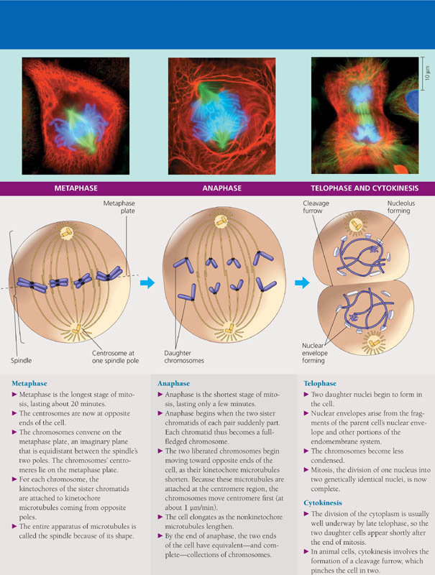
METAPHASE
____________________________________________
____________________________________________
____________________________________________

ANAPHASE
_____________________________________________
_____________________________________________
_____________________________________________
_____________________________________________

TELOPHASE
_____________________________________________
_____________________________________________
_____________________________________________
_____________________________________________

CYTOKINESIS = DIVISION OF CYTOPLASM
_____________________________________________
_____________________________________________
_____________________________________________

